Ideation Phase
Brainstorm & Idea Prioritization

Date | 31 January 2025
Team ID | LTVIP2026TMIDS65742
Project Name | FlightFinder: Navigating Your Air Travel Options
Maximum Marks | 4 Marks

Brainstorm & Idea Prioritization Template:
Design and develop a web-based flight booking application that enables users to search, compare, book, and manage flights efficiently with secure payments and real-time flight tracking.
Step-1: Team Gathering, Collaboration and Select the Problem Statement
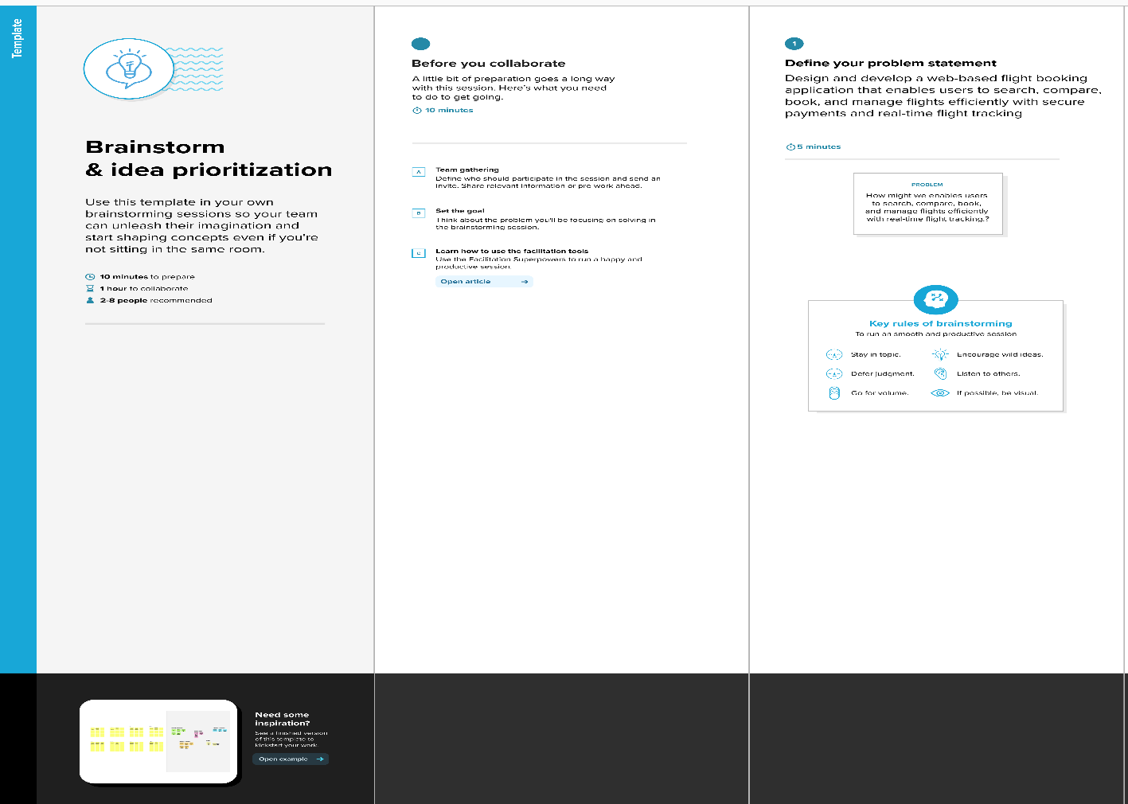

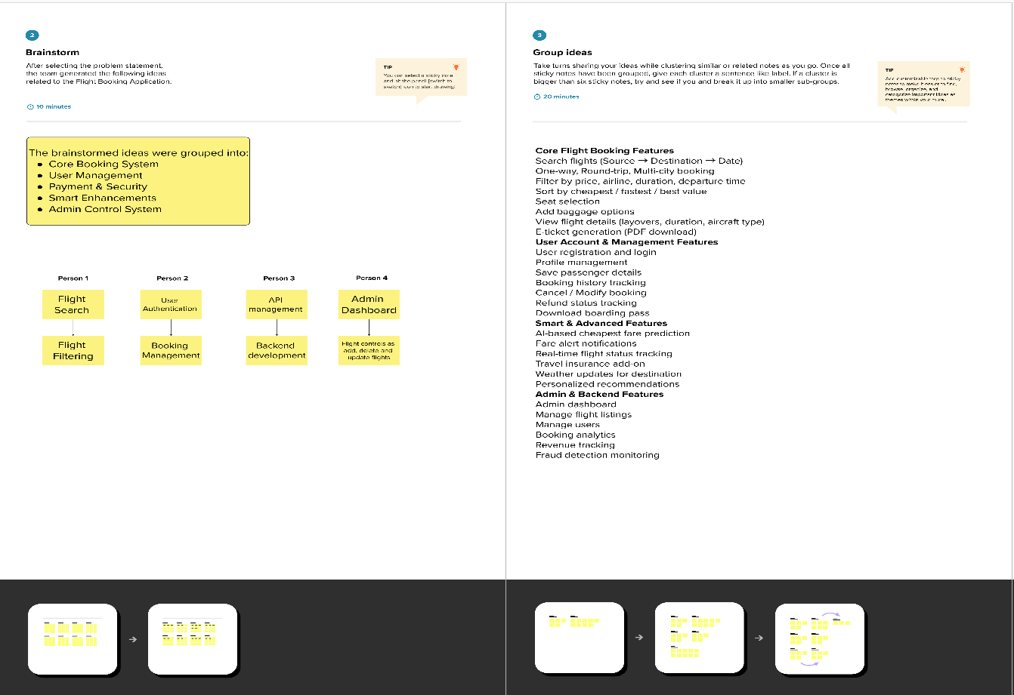
Step-2: Brainstorm, Idea Listing and Grouping

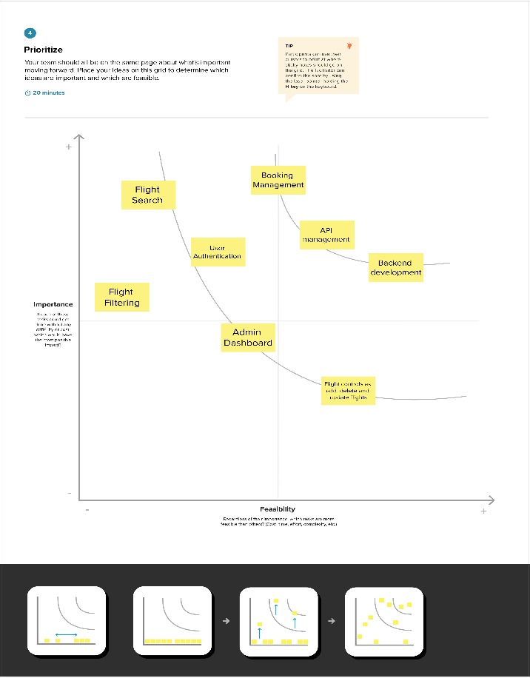
Step-3: Idea Prioritization

